# Scenario:

Douglas Financials Inc (DFI from here forward) has experienced successful growth and as a result is ready to add a Security Analyst position. Previously Information Security responsibilities fell on our System Administration team. Due to compliance and the growth of DFI we are happy to bring you on as our first InfoSec employee! Once you are settled in and finished orientation, we have your first 2-Weeks assignments ready.

## Week One:

### 1. **Connect:**

All the subsequent steps will take place in the DFI environment. You will need to RDP into the Windows 10 workstation and use it to connect with the Windows and Linux servers provided using RDP and SSH (via PowerShell) respectively.

[Please Provide Screenshots of the RDP and SSH here as evidence that you completed this step.]

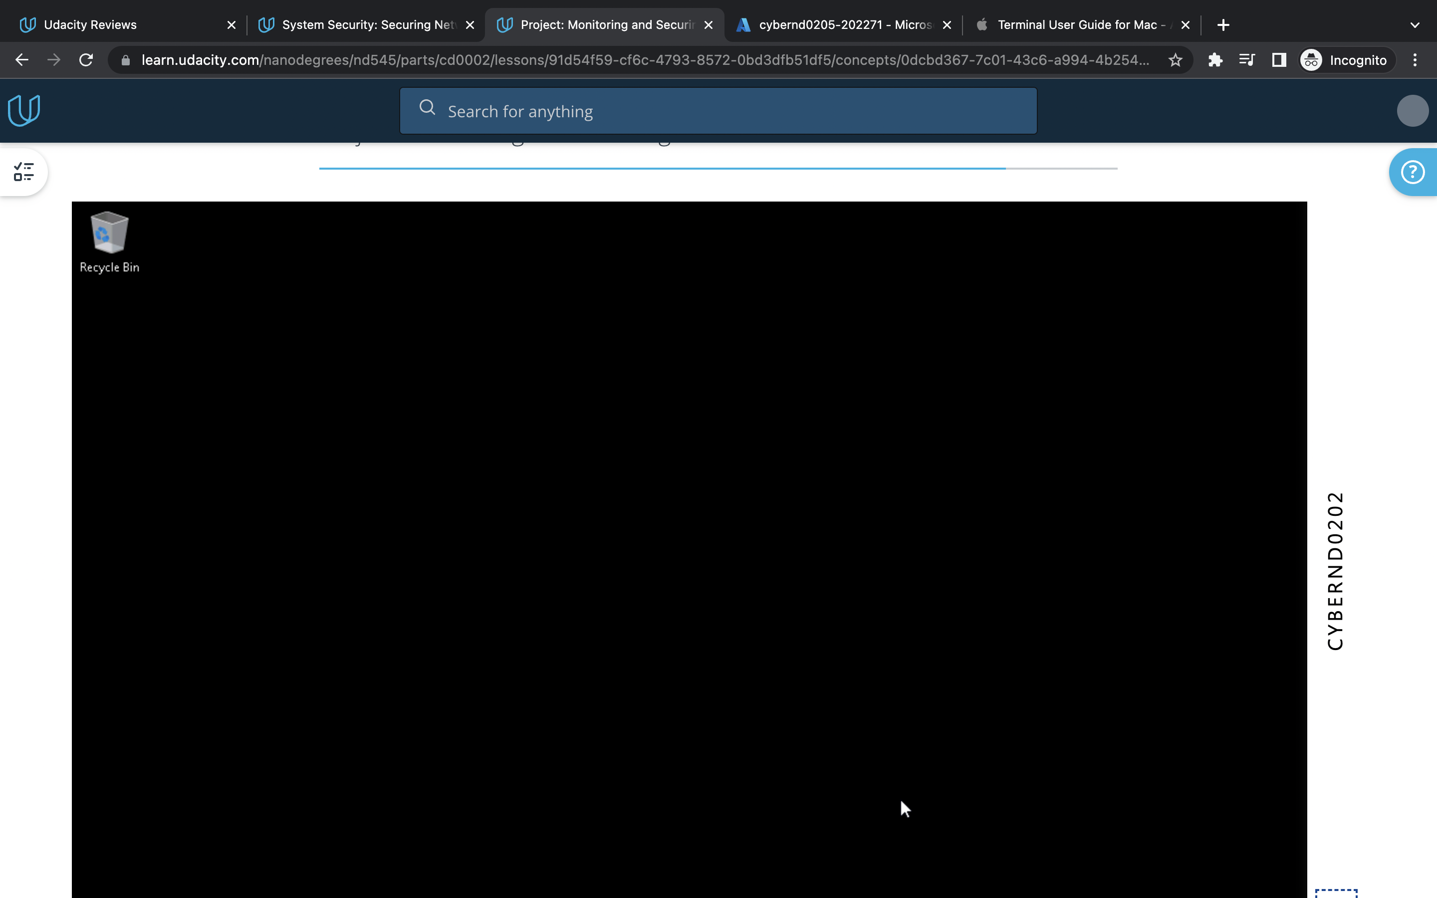

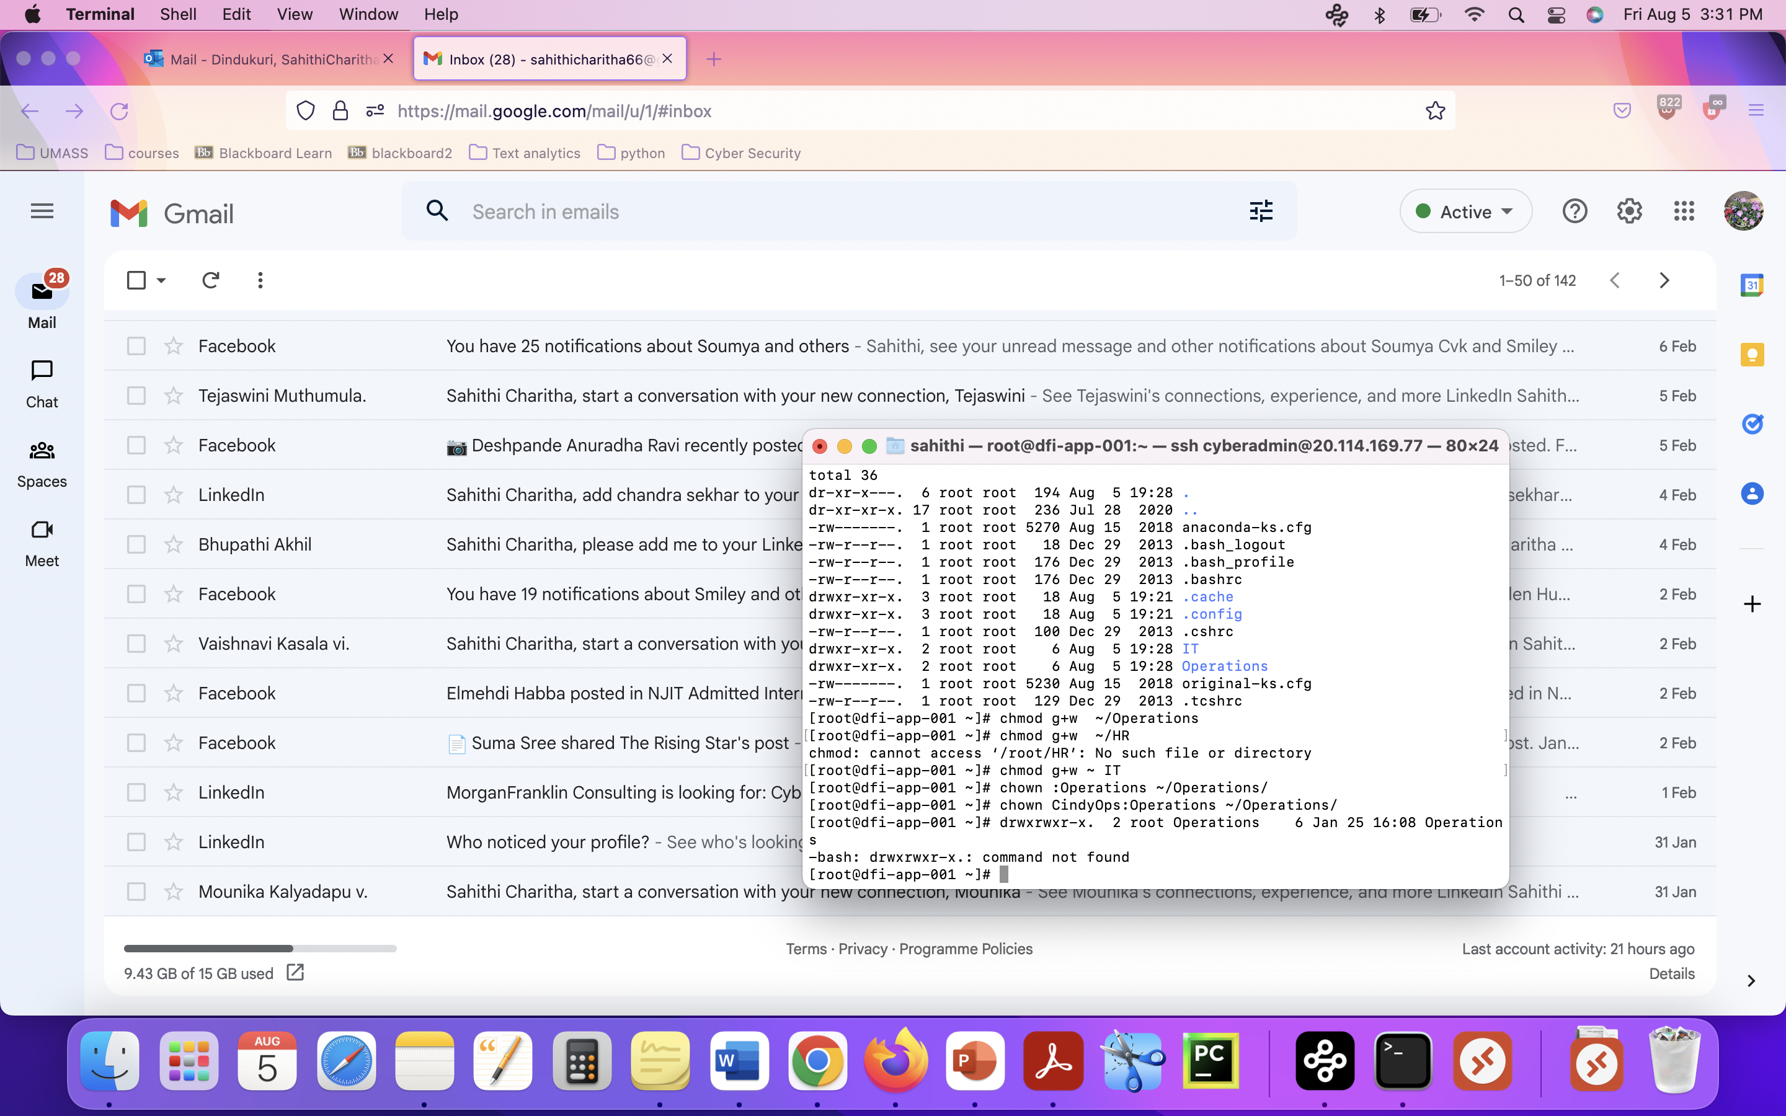

### 2. **Security Analysis:**

DFI has an excellent SysAdmin team, but they have been focused on system reliability and scaling to meet our growing needs and as a result, security may not be as tight as we'd like. Your first assignment is to familiarize yourself with our file and application servers.

Please perform an analysis of the Windows server and provide a written report detailing any security configuration issues found and a brief explanation and justification of the changes you recommend. DFI is a PCI compliant organization and will likely be Sarbanes-Oxley in the near future.

Use NIST, Microsoft, Defense-in-Depth, Principle of Least Privilege, and other resources to determine the changes that should be made. Note changes can be to **add**/**remove/change** services, permissions, and other settings. [Defense-in-Depth documentation.](http://iieng.org/images/proceedings_pdf/8285E0914047.pdf) [NIST 800-123](https://nvlpubs.nist.gov/nistpubs/Legacy/SP/nistspecialpublication800-123.pdf) (other NIST documents could also apply.)

Ans:

According to NIST guidelines to general server security unnecessary services should be removed example: Xbox live auth manger, Xbox game server

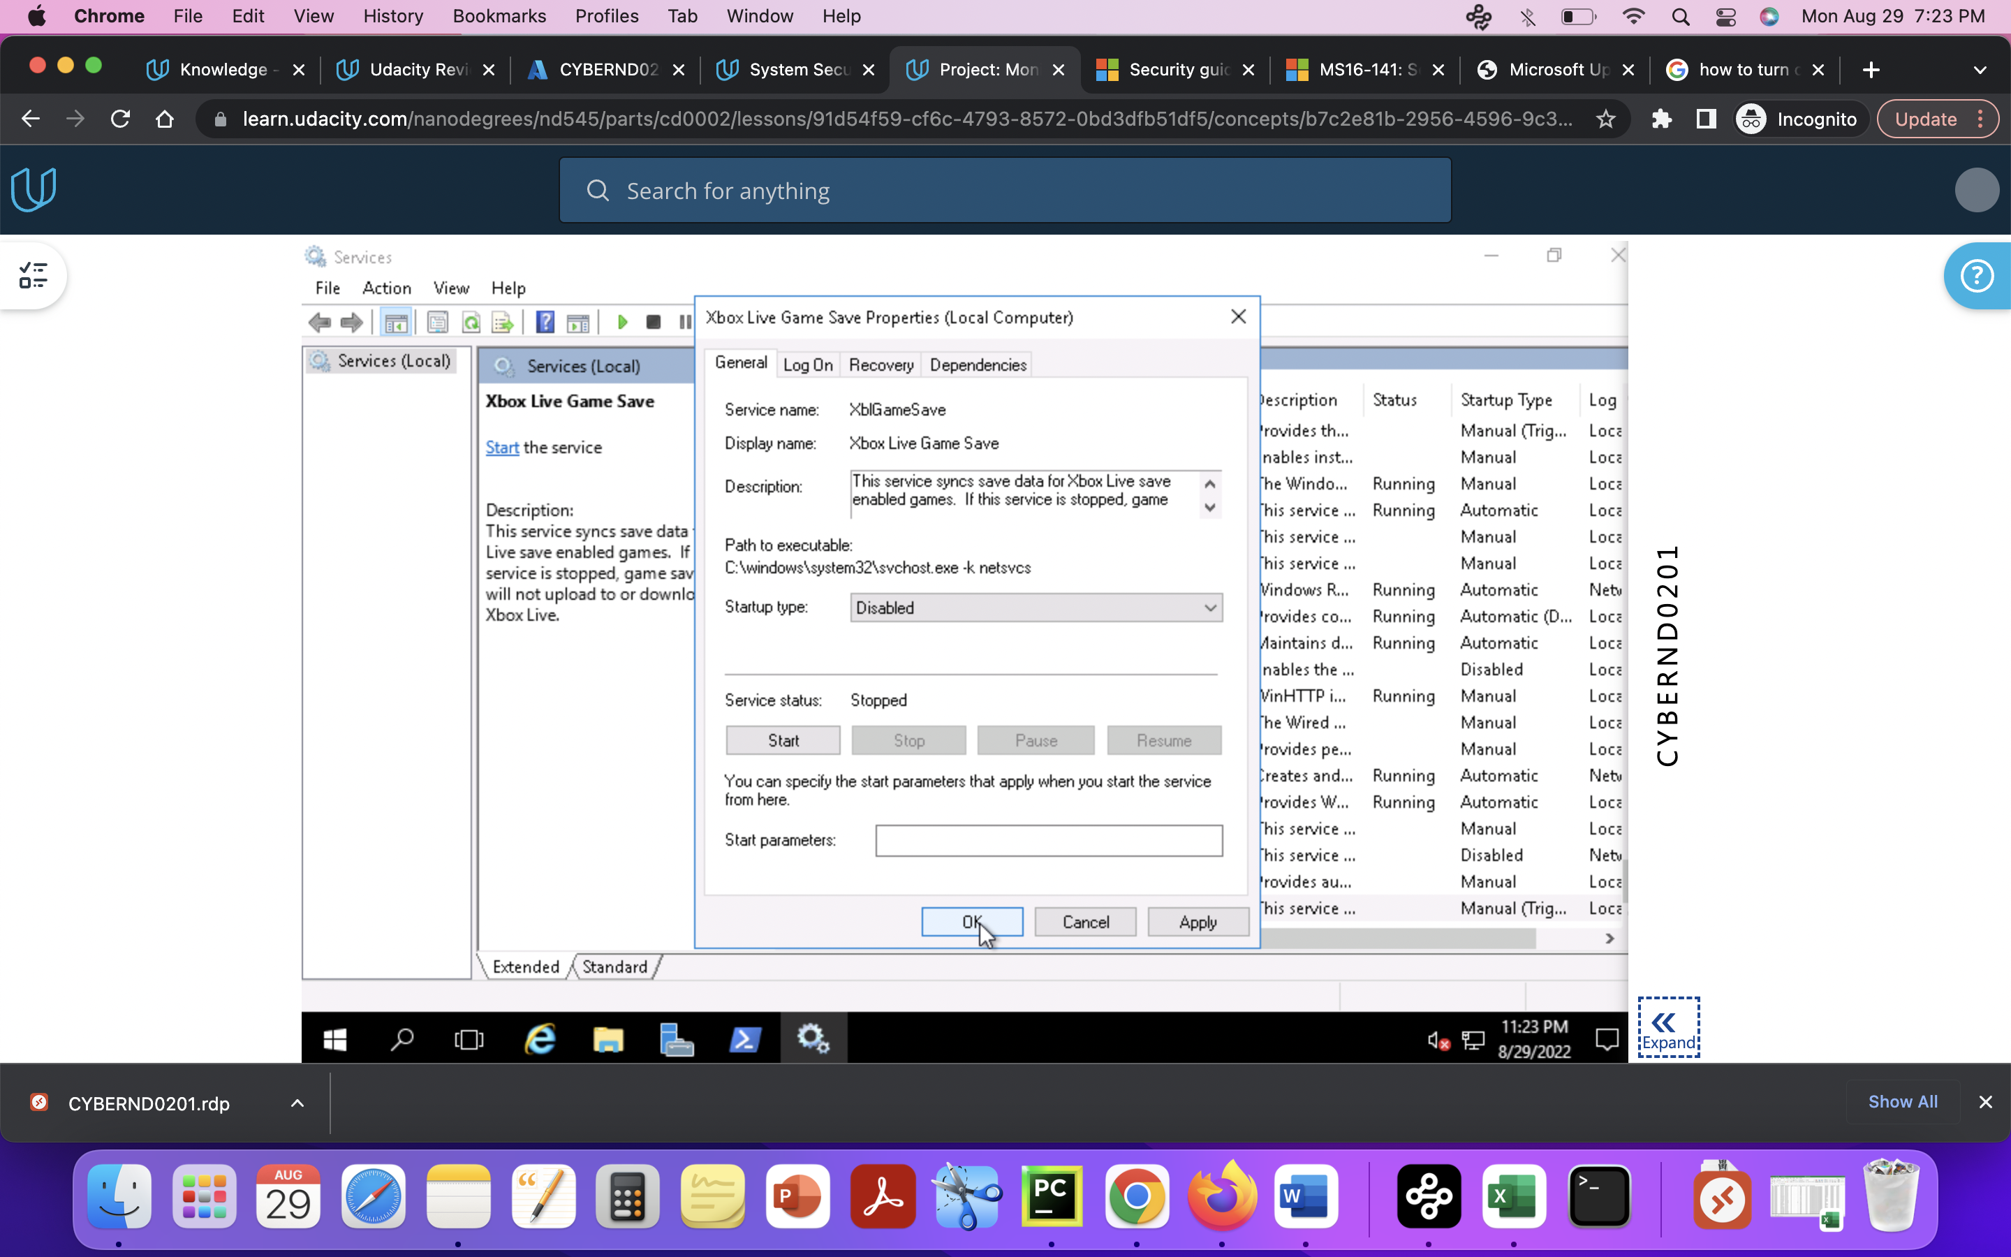

Enabled windows updates. Updating is a good practice, it can help with reducing the attacks.

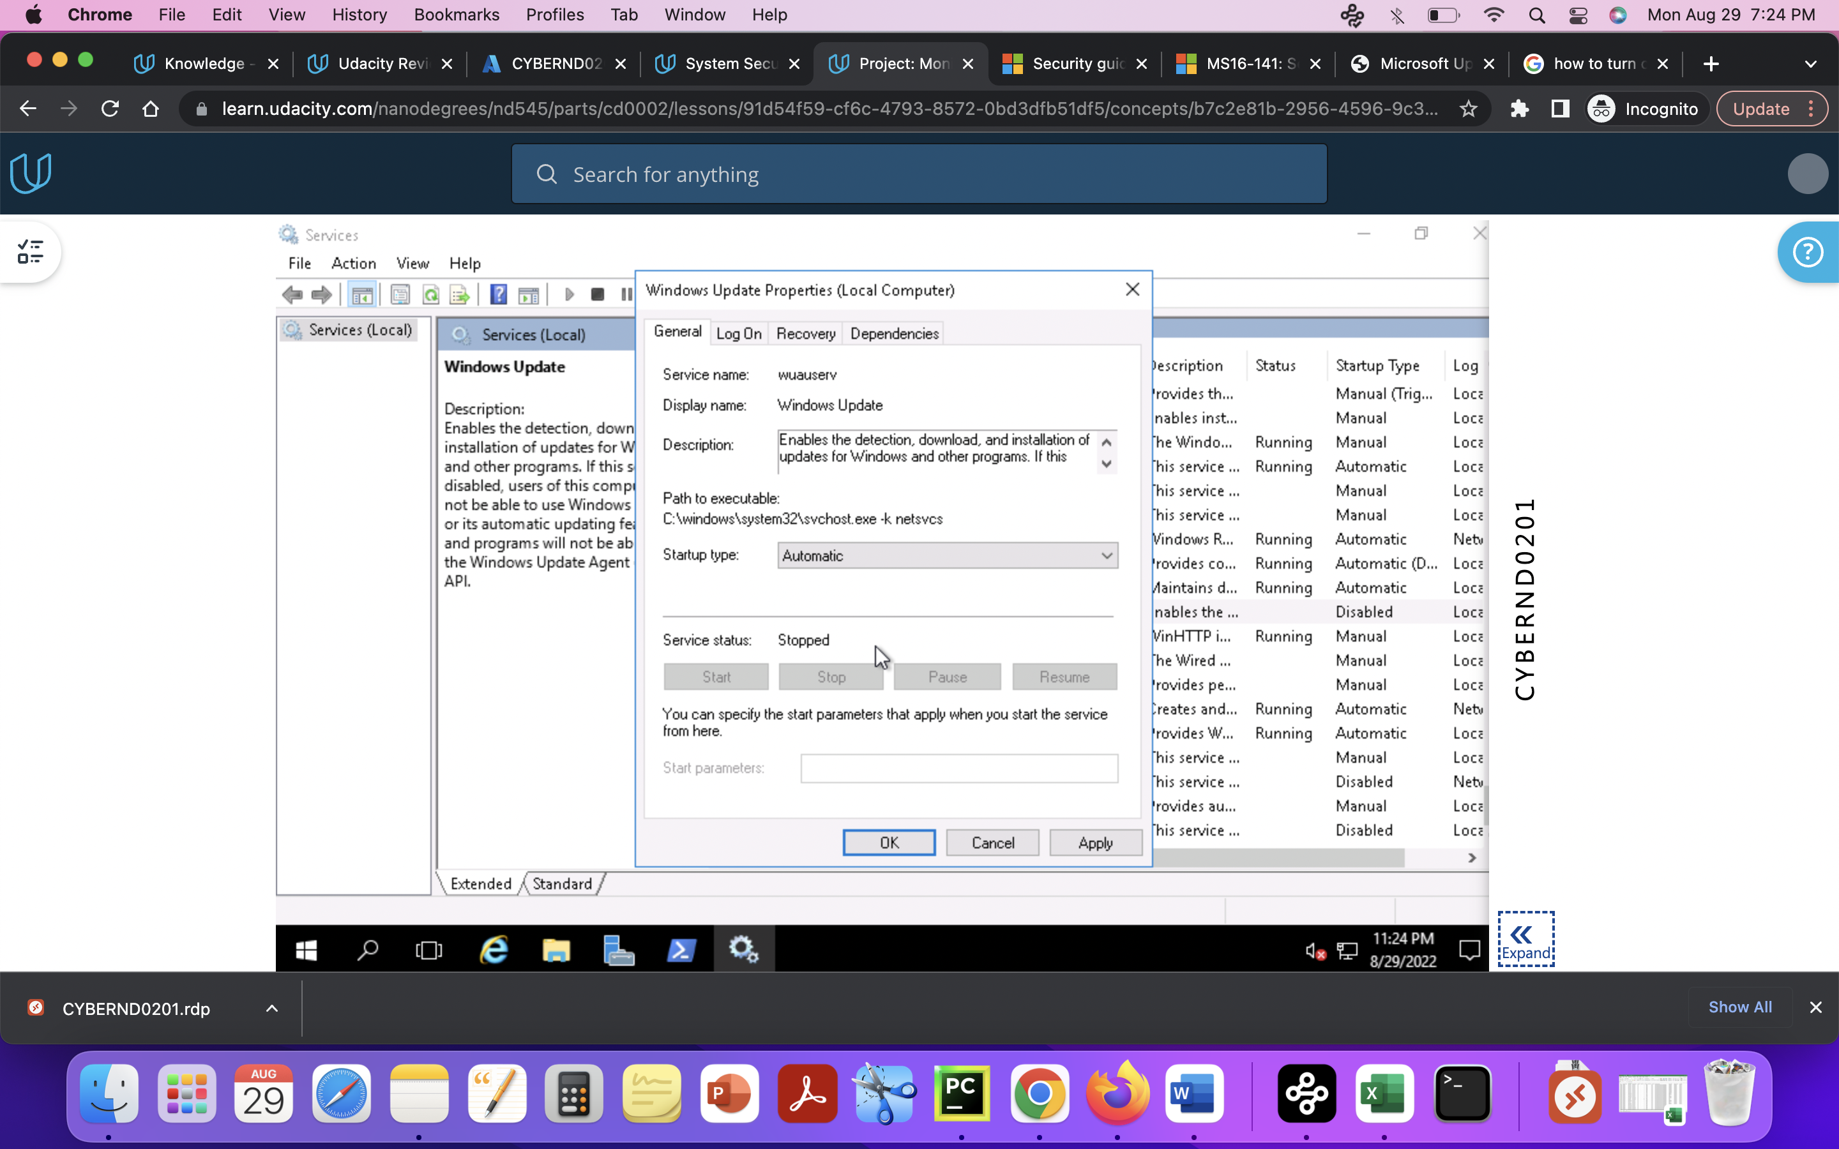

Removed print server: As DFI is a PCI complaint organization print server is not necessary

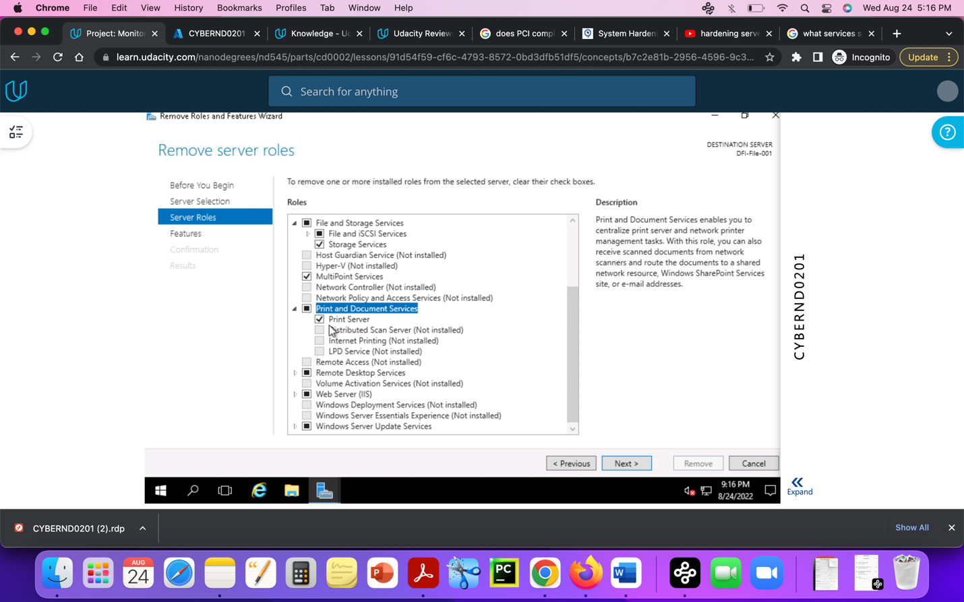

Remote Desktop services are not necessary (it can be used with high security and authorization techniques)

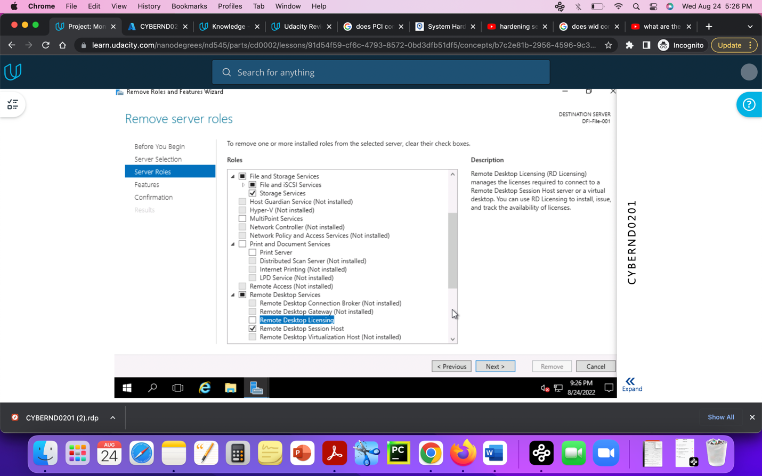

File permission on HR folder: except for the HR team other groups like Accounting, IT should not have full permissions, users should only have read list the contents access, they may have executed option but not modify or write the files.

File permissions for IT department folder: same changes applied to IT and operations folders

Unlike these folders public folder may have full access to everyone

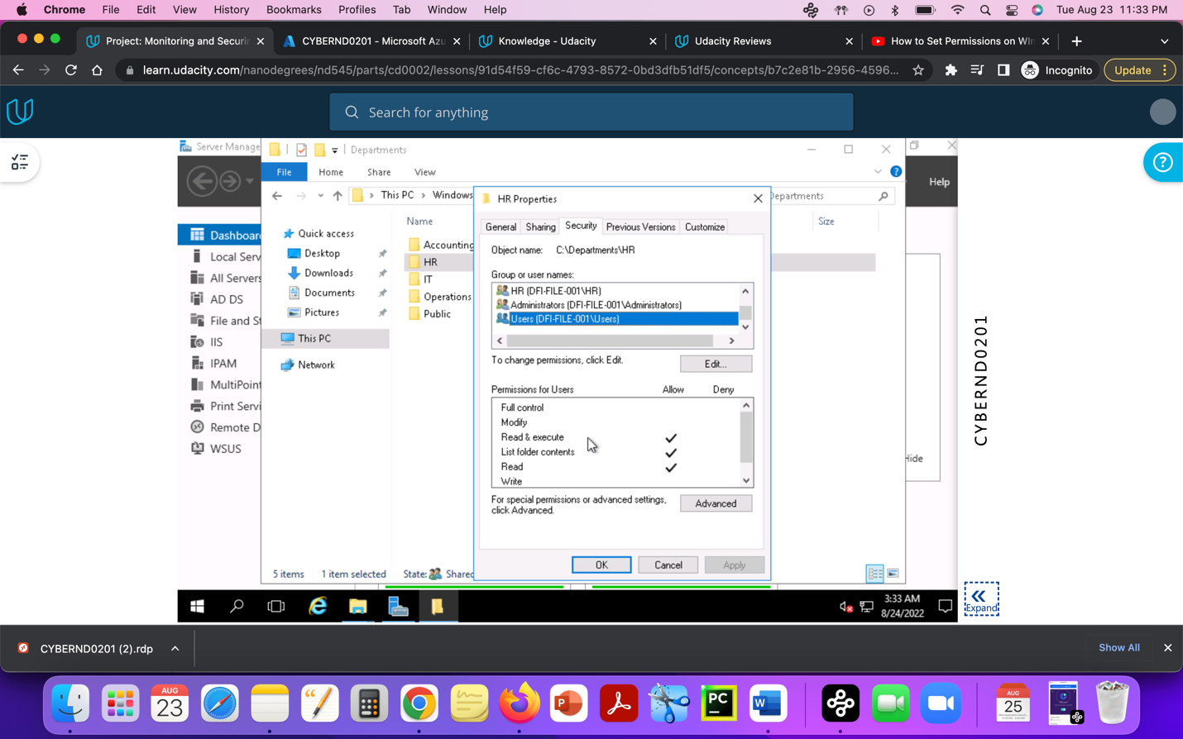

### 3. **Firewall Rules:**

DFI does not have a dedicated networking department just yet, once again these tasks normally fall under the SysAdmin group. Now that we have you as a security professional, you'll take over the creation of our firewall rules. We recently entered into a new partnership and require new IP connections.

Using Cisco syntax, create the text of a firewall rule allowing a new DFI partner WBC International, access to DFI-File-001 access via port tcp-9082.

The partner's IP is 21.19.241.63 and DFI-File-001's IP is 172.21.30.44.

For this exercise assume the two IP objects **have not** been created in the firewall. **Note**\* Use *DFI-Ingress* as the interface for the rule. For documentation purposes, please explain the syntax for non-technical management on the change control board that meets weekly.

[access-list DFI-Ingress extended permit tcp host 21.19.241.63 host 172.21.30.44 eq 9082]

Access-list = controls the traffic

DFI-ingress = interface used here

Extended permit helps to match based on IP addresses

Tcp= protocol used here

Eq means equal to

9082 is the port number

### 4. **VPN Encryption Recommendation:**

DFI is creating a payroll processing partnership with Payroll-USA, this will involve creating a VPN connection between the two. Research, recommend and justify an encryption solution for the connection that is using the latest available encryption for Cisco. Use the Cisco [documentation](https://tools.cisco.com/security/center/resources/next_generation_cryptography) as a guide.

[ IPSec vpn encryption, it provides security for internet protocol which authenticates, encrypt the data. As per the cisco guidelines for vpn encryption while setting up the IPSec vpn do not use NULL encryption use both authentication and encryption methods for better security.]

### 5. **IDS Rule:**

The System Administrator gave you a heads up that DFI-File-001 with an IP address of 172.21.30.44 has been receiving a high volume of ICMP traffic and is concerned that a DDoS attack is imminent. She has requested an IDS rule for this specific server.

The VoIP Administrator is also concerned that an attacker is attempting to connect to her primary VoIP server which resides at 172.21.30.55 via TFTP. She has requested an IDS rule for this traffic.

For documentation purposes, please explain the syntax for non-technical management on the change control board that meets weekly.

[Place your System Admin rule and explanation here]

[alert icmp any any -> 172.21.30.44/55 69 (msg: “DDoS attack attempt”; sid:1000020;)]

Alert = with this rule option snort will create an alert

Any = snort will look for different source ip

Any = snort will look for different source ports

172.21.30.44 = destination ip

Msg = that message will display in the alert

Sid = snort id which is usually greater than million

ICMP = internet control remote protocol, do not have any specific port generally used the “ping” processes

DDOS= denial of service attack, attack caused by sending large amount of data(explotable) so that servers may work slowly or stops.

[Place your VoIP Admin rule and explanation here]

[alert tftp any any -> 172.21.30.55 69 (msg: “VoIP connection attempt”; sid:1000021;)]

VoIP = Voice over internet protocol is used for voice communications

69 = destination port number for tftp

Alert = with this rule option snort will create an alert

Any = snort will look for different source ip

Any = snort will look for different source ports

TFTP = Trivial File Transfer Protocol, used in transmission of documents remotly

### 6. **File Hash verification:**

A software vendor has supplied DFI with a custom application. They have provided the file on their public FTP site and e-mailed you directly a file hash to verify the integrity and authenticity. The hash provided is a SHA256.

**Hash**: 7805EC4395F258517DFCEEED2B011801FE68C9E2AE9DB155C3F9A64DD8A81FF6

Perform a file hash verification and submit a screenshot of your command and output.

The File is stored on the Windows 2016 Server in C Drive under DFI-Download.

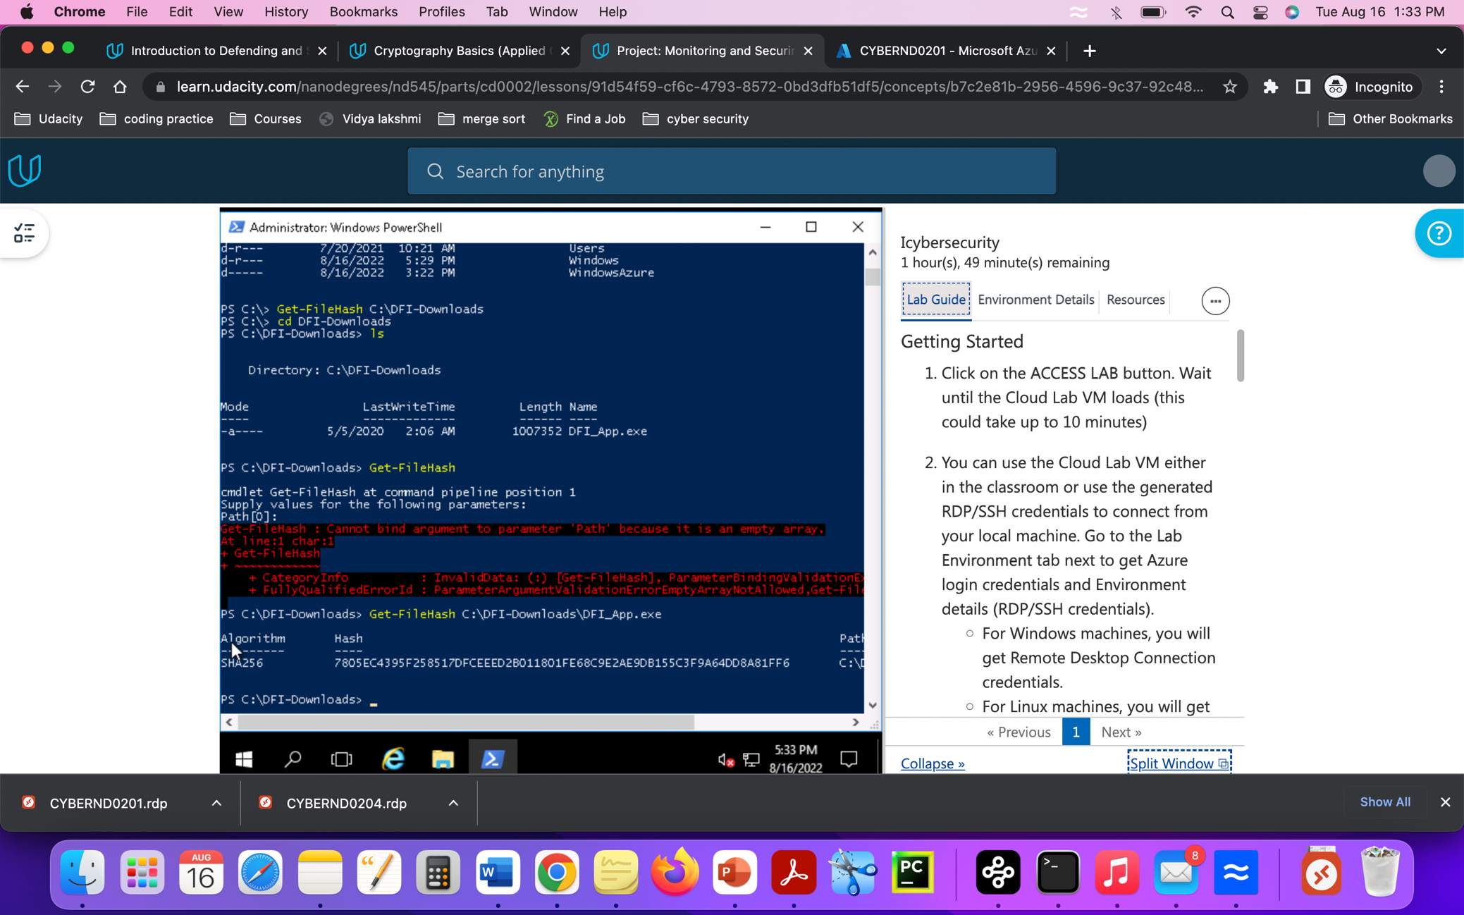

## Week Two:

Now that you've performed a light audit and crafted Firewall and IDS Signatures, we're ready for you to make some additional recommendations to tighten up our security.

### 7. **Automation:**

The IT Manager has tasked you with some introductory research on areas that could be improved via automation.

Research and recommend products, technologies, and areas within DFI that could be improved via automation.

Recommended areas are:

* SOAR products and specifically what could be done with them
* Automation of mitigation actions for IDS and firewall alerts.
* Feel free to elaborate on other areas that could be improved.

Complete the chart below including the area/technology within DFI and a proposed solution, with a minimum of 3 areas. Provide a brief explanation for your choices.

|  |  |  |
| --- | --- | --- |
| **DFI Area/Technology** | **Solution** | **Justification for Recommendation** |
| SOAR | Cyber bit- cyber-Range | It is a Simulation platform allows. For training, development. |
| SOAR | Rapid7 | Monitor and shutdown malware attacks, automates operations |
| SOAR | Palo alto networks | It has number of tools for security and business growth, advanced firewalls, cloud-based techniques |
| IDS/IPS | Suricata | Threat detection software like Snort, helps with packet inspection, pattern matching |
| Firewall protection | CISCO NGFW | Gives advanced threat protection, application control, and integrated IPS |
| Firewall | Dynamic Blacklist | Is used to block the ip for multiple SSH attempts, it has adapting behavior |

### 8. **Logging RDP Attempts:**

The IT Manager suspects that someone has been attempting to login to DFI-File-001 via RDP.

Prepare a report that lists unsuccessful attempts in connecting over the last 24-hours. Using PowerShell or Event viewer, search the Windows Security Log for Event 4625. Export to CSV.

For your deliverable, open the CSV with notepad and take a screenshot from your personal computer for your explanation. Please also include this file in your submission. Then in your report below explain your findings, recommendations, and justifications to the IT Manager.

[Place IT Manager Report Here]

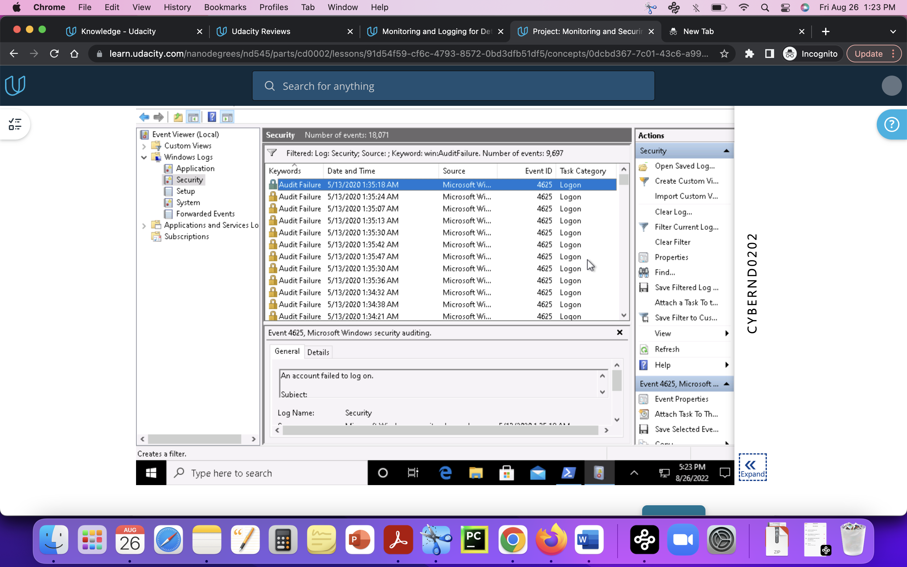

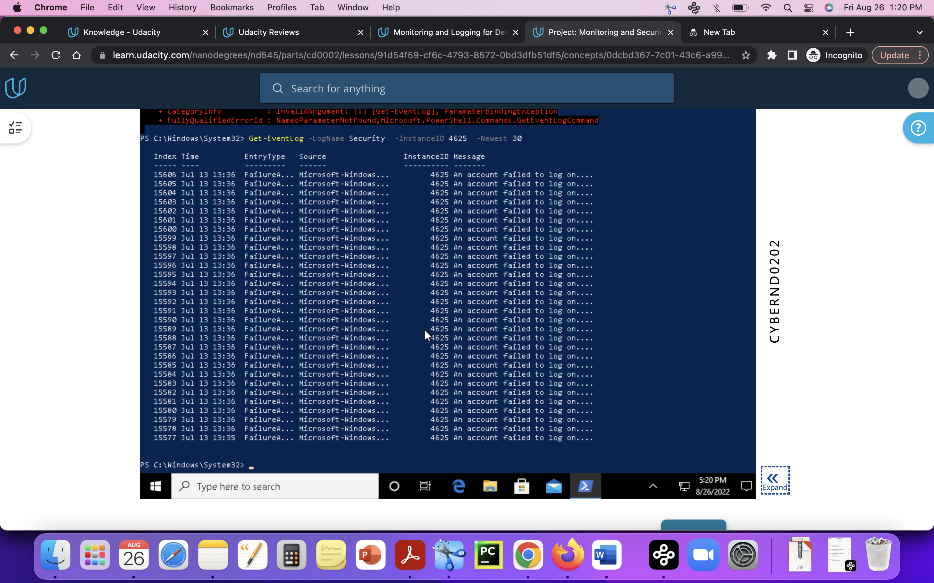

**Observations** from the report:

A source Ip 95.17.106.4 tried to login and failed multiple times, the report says it tried from different accounts like administrator account and user account, admin account. Failure reason says bad password or unknown username. in one day at the same time with mintues difference the attacker tries the login attempts.

**Recommendations**:

* monitor logs using SIEM, Security Information and Event Management monitor the logs and generates security alerts. It will help the analyst to check the logs with security significance.
* Use Two factor verification or multi factor verification.
* Allow only trusted IP’s over secure way by using TLS.
* Use Least privilege concept and give minimum level of permissions to work.
* Use Vpn connection.
* Keep delays after failure login sessions, block the ip which seems suspsious or after 3 failure login attempts

### 9. **Windows Updates:**

Using [NIST 800-40r3](https://nvlpubs.nist.gov/nistpubs/SpecialPublications/NIST.SP.800-40r3.pdf) and [Microsoft Security Update Guide](https://portal.msrc.microsoft.com/en-us/security-guidance), analyze the windows servers and provide your answers in the table below of available updates (KB and CVE) that should be installed as well as any updates that can be safely ignored for DFI's purpose. To assist, be aware that DFI is concerned with stability and security, any update that is not labeled as a 'critical' or 'security' can be left off.

Justify your recommendations as to why you are making your choices.

Add as many rows or additional columns as you need to the table.

|  |  |  |
| --- | --- | --- |
| Available Updates | Update/Ignore | Justification |
| KB 3202790 | Update-critical update-security update for Adobe flash player | Justification: successful exploitation may lead to code execution which is critical |
| KB 4550994 | Update – critical update – Servicing stack update | Justification: SSU is responsible for the windows updates, this update will help with receive and install the updates |
| KB 4556813 | Update -critical- cumulative security update for Microsoft edge | Justification: a system with missing this update may leads to different vulnerabilities like DDOS, Remote code execution and information disclosure |
| CVE-2022-35822 | Can be ignored-important update- Windows Defender credential Guard Security feature bypass Vulnerability | Justification: attack vector is local, vulnerable compound is not attached to network and the attacker is dependable on authorized user. So can be avoidable if the user is careful with the vulnerabilities. |
|  |  |  |
| CVE 2022-21980 | Update-critical- Elevation of privilege vulnerability - Issue resolved: Start-DatabaseAvailabilityGroup fails with BlockedDeserializeTypeException (KB5017261), | Justification: attack vector is network, so it is “remotely exploitable” and it is in the protocol level, elevation of privilege exploitation is critical it leads to other kinds of attacks too. |

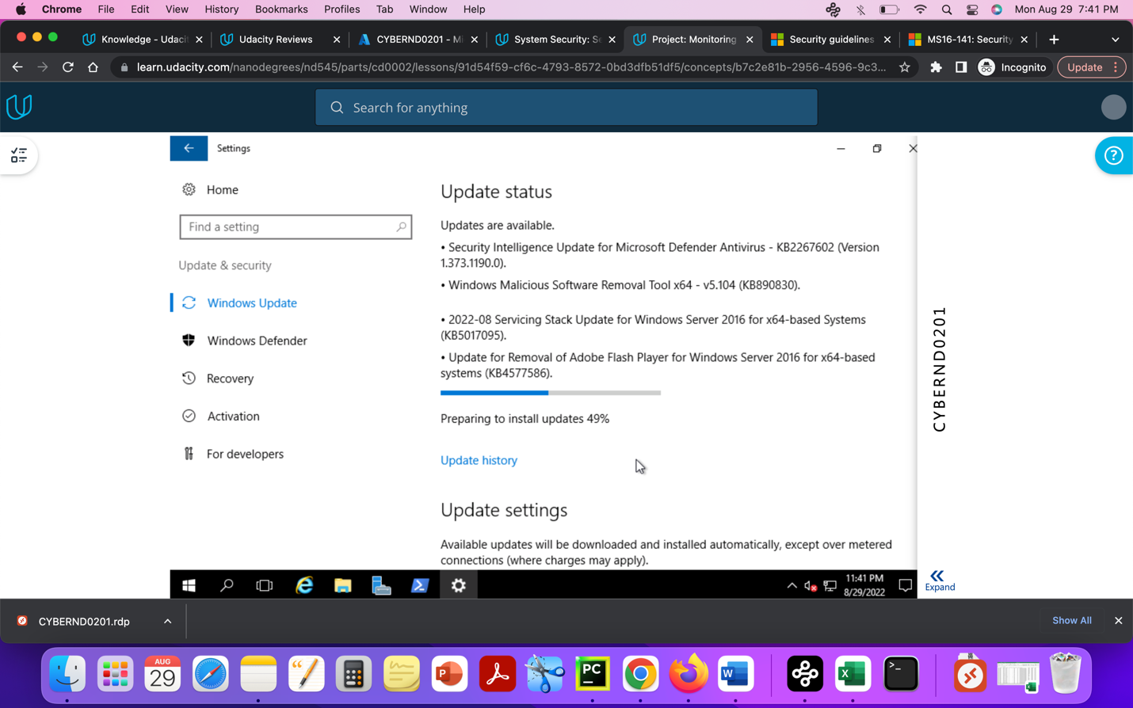

### 10. **Linux Data Directories:**

The IT Manager has requested your help with creating directories on the CentOS server DFI-App-001 (reachable by ssh from the Windows 10 machine. in the DFI subnet.)

* The root directory should be 'Home'
* The first subdirectory should be "Departments" with subdirectories: HR, Accounting, Public, IT and Operations.
* Set owner permissions for the groups IT, HR, Operations and Accounting
* Create the users AmyIT, PamOps, MandyAcct and TimHR in the appropriate groups so that they can read/write/execute in their respective departmental folders.

For documentation purposes, please explain the syntax for non-technical management on the change control board that meets weekly.

[Provide a screenshot(s) of completed tasks and the correctly set permissions here]

1. Created Home Directory using mkdir command in terminal

Created Departments1 sub-directory, under departments created different groups using groupadd command

Created users using adduser command

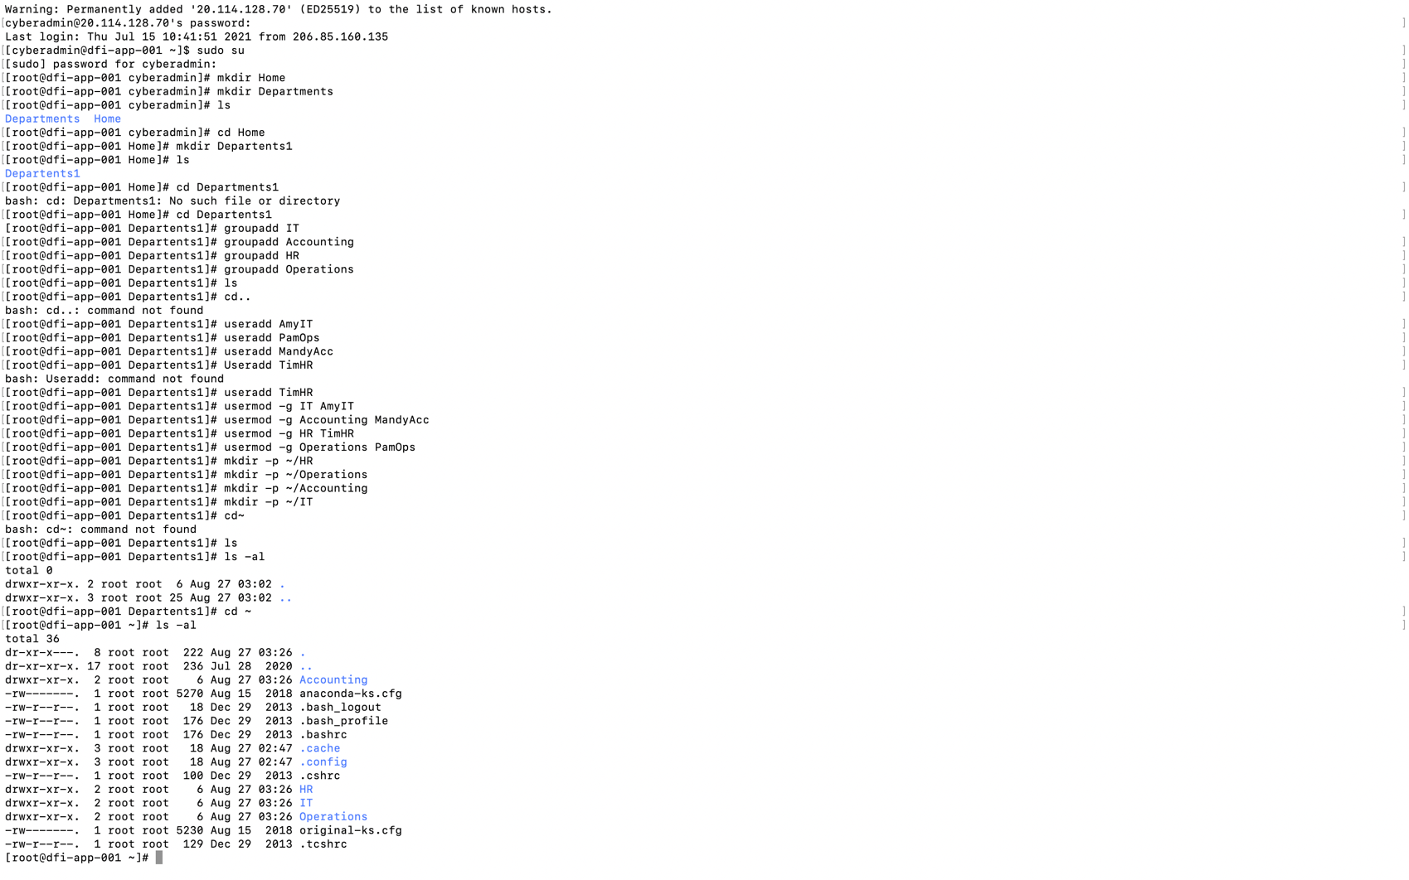

1. Added Users to the respective groups using usermod -g command

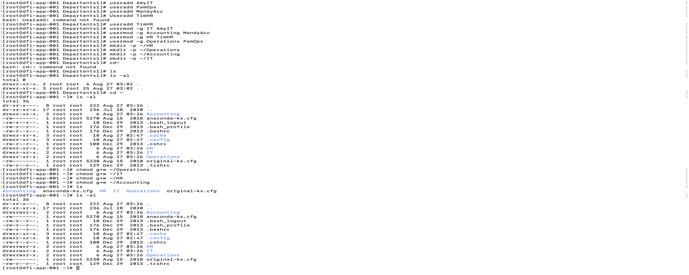

1. changed read/write permissions, chown command will helps to give owner permissions to the user to the respective group, read write permission changed from drwxr-xr-x to drwxrwr-x

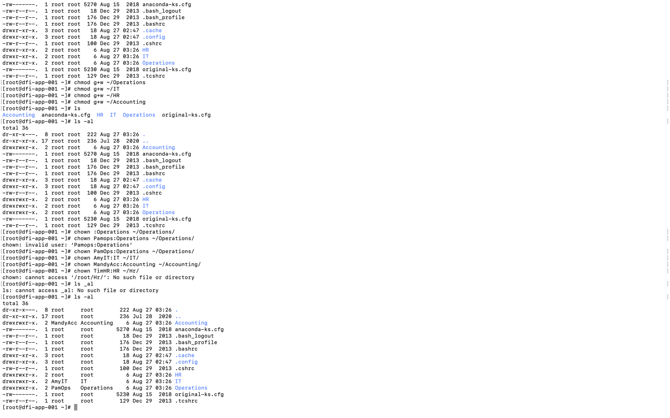

### 11. **Firewall Alert Response:**

The IT Manager took a look at firewall alerts and was concerned with some traffic she saw, please take a look and provide a mitigation response to the below firewall report. Remember to justify your mitigation strategy.

This file is available from the project resources title: **DFI_FW_Report.xlsx**. Please download and use this file to complete this task.

[Firewall mitigation response and justification goes here]

**Analyzing the report:**

* Highest number of attacks are from the ip address 45.35.0.252, it has multiple repeating attempts of brute force attack on the destination port.
* The attacks from Korea are also high which is from the ip address 39.116.31.62
* It can be seen from the report the ip address 192.34.57.157 has tried brute force attacks multiple times from different port addresses.
* The ip address 34.201.223.194 attempted to brute force attack from different ports, multiple times using the same port address.
* The ip address 213.91.162.133 has tried 140 plus attempts repeatedly in a single time, which is from Bulgaria
* Overall, attack is initiated from different countries, from different ips and different source ports, several times.

**Mitigation steps:**

* Use SSH hardening techniques, limit the number of login attempts,
* Use Next generation firewalls like WAF firewalls
* Use Intrusion Prevention system at the entrance. Example: **Fail2ban**, it helps to monitor logs and suspicious activity. It will block the ips after defying multiple failed attempts, also prevents from unauthorized access.
* Use the strong password and change it frequently after every 60 days (depends on the organization)
* Use two factor authentication technique and keep time delays after every attempt, make use of captcha

### 12. **Status Report and where to go from here:**

As your first two weeks wind down, the IT Manager, HR Manager as well as other management are interested in your experience. With your position being the first dedicated Information Security role, they would like a 'big picture' view of what you've done as well as the security posture of DFI.

Similar to Defense-in-Depth, an organization has multiple layers of security from the edge of their web presence all the way to permissions on a file.

In your own words explain the work you've done, the recommendations made and how DFI should proceed from a security standpoint. This is your opportunity to provide a thoughtful analysis that shows your understanding of Cyber Security and how all the tasks you've performed contribute to the security of DFI. As this will be reviewed by non-technical management, please keep the technical jargon to a minimum.

[Provide your Status Report Here]

* Overall to secure the environment follow the least privilege rules and reduce the permission to the user groups- ex: IT team should have the full permissions; HR team should not have full permissions.
* Windows upgrades and patches are also playing an important rule, they will help reducing the attacks.
* Use automation techniques for firewalls and IPS. A firewall is the first step in the attack prevention methods.
* Always monitor the logs.
* Follow the PCI compliance check list, as the customers data is confidential any security draw back may cause huge loss to the organization and customers. As they deal with customers financial docs the confidentiality, integrity and availability should be HIGH.
* Have a subscription to Dynamic block list which will help with blocking set of suspicious Ip addresses.
* Follow Nist sp800 rules for hardware, software security.
* Use office systems for only work purposes any unrelated apps, services should be uninstalled.

### 13. **File Encryption:**

As your final task, assemble all of the deliverables you have created in Steps 1-12 and encrypt them using 7zip with a strong password.

**When you submit the file you must also include your password as a note to the reviewer at Udacity or they will not be able to review your project.**